Order Of Service

Singing: Psalm 27—CW page 75

Reading: Psalm 20

Opening Hymn: TLH 227

Reading: Revelation 4

Request Hymn: CW Supplement 735

Reading: John 5:19-29

Sermon Hymn: TLH 236

Sermon Text: Song Of Solomon 4:15

Filled With The Holy Spirit

Prayer

The Apostles’ Creed, TLH page 12

Holy Communion

The Lord's Prayer

The Blessing

Closing Hymn: TLH 234

* * * * * * * * * * *

Bible Study: Lambs: Psalm 1:2; Spending Time With God
Sheep: Proverbs 11:7-8
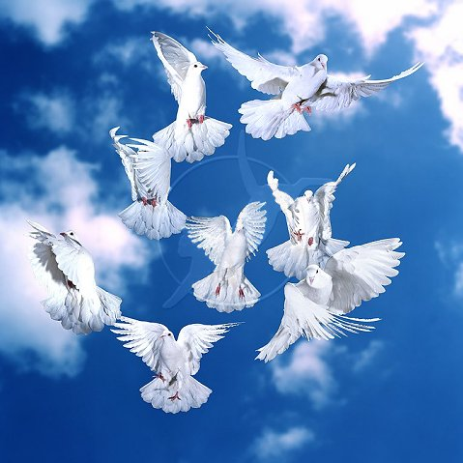

Filled With The Holy Spirit

Water
Of
Life

23 October 2016

W A T E R O F L I F E

Independent Christian Church—Conservative Lutheran Doctrine

Worship Service: 9:30 a.m. Bible Study: 10:45 a.m.

Larry Cooper, Pastor E-Mail address:
111 N. Ridge Road lcooper@wateroflife.cc
Coon Valley, WI 54623 Web Site:
Phone: (608) 452-2105 www.wateroflife.cc

* * * * * * * * * * * * * * * * * * * * * * * * * * *

Sermon Text: Song Of Solomon 4:15

Filled With The Holy Spirit

* * * * * * * * * * * * * * * * * * * * * * * * * * *

Song of Solomon 4:15 A fountain of gardens, a well of living waters, and streams from Lebanon.

Here at the close of chapter four of Song Of Solomon, the Bridegroom is commenting on the beauty of his Bride. The final three things he mentions are that she is: a fountain of gardens; a well of living waters; and streams from Lebanon.

The main theme here is WATER. A lot of it!!! And water here is a symbol of the Holy Spirit. We think of John 7:37-39:

37 In the last day, that great day of the feast, Jesus stood and cried, saying, If any man thirst, let him come unto me, and drink.
38 He that believeth on me, as the scripture hath said, out of his belly shall flow rivers of living water.
39 (But this spake he of the Spirit, which they that believe on him should receive: for the Holy Ghost was not yet given; because that Jesus was not yet glorified.)



Notice the comparison between Song Of Solomon 4:12 and 4:15:
:12 a garden inclosed; :15 a fountain of gardens; :12 a spring shut up; :15 a well of living waters; :12 a fountain sealed; :15 streams from Lebanon. We believe verse 15 is a picture of the Bride in her glorified state in Christ’s Kingdom of Glory.

